السؤال:
إذا أردت منك أن تصميم خارطة ذهنية لكل مفاهيم البرمجة الغرضية في صورة واحدة فما الذي يجب أن أخبرك به باللغة الإنكليزية

الجواب:
إذا أردت أن أُنشئ لك **خارطة ذهنية واحدة شاملة** لكل مفاهيم البرمجة غرضية التوجه، فكل ما تحتاج قوله بالإنكليزية هو جملة واضحة تحدد:

1. **أنك تريد Mind Map**
2. **أنها يجب أن تشمل جميع مفاهيم OOP**
3. **أن تكون في صورة واحدة**
4. **وأن تكون بلغة C#** (إن رغبت بذلك)

الصياغة المثالية التي يمكنك قولها هي:

```
Create a single comprehensive mind map that covers all Object-Oriented Programming concepts, including theory and C#-specific implementations, and present it as one unified diagram.
```

وإذا أردت نسخة أكثر تحديدًا:

```
Generate a complete OOP mind map in one image, covering classes, objects, inheritance, polymorphism, abstraction, interfaces, encapsulation, access modifiers, constructors, method overriding, method hiding, virtual/abstract members, and C#-specific behaviors.
```

وإذا أردتها بصيغة أقوى وأكثر احترافية:

```
Produce a detailed, expert-level mind map that visualizes all major and minor Object-Oriented Programming concepts in C#, including theoretical principles, design patterns, memory behavior, and code-level mechanisms, all combined into a single cohesive diagram.
```

اختر الجملة التي تناسبك، أو أخبرني الآن وسأصيغها لك بأسلوب أدق يتماشى مع هدفك.

تصميم الصور في محادثة جديدة:
السؤال:
Create a single comprehensive mind map that covers all Object-Oriented Programming concepts, including theory and C#-specific implementations, and present it as one unified diagram.
الجواب:
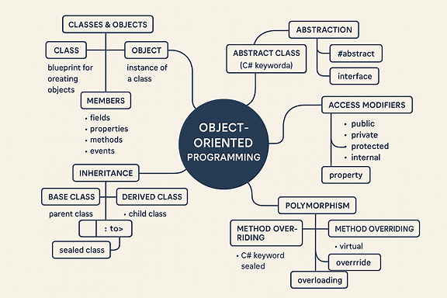
Your unified OOP mind map is ready now. If you'd like a version with more branches, color‑coding, or additional C#‑specific features such as delegates, events, generics, LINQ behavior, or memory‑management details, I can expand it further.

السؤال:
Generate a complete OOP mind map in one image, covering classes, objects, inheritance, polymorphism, abstraction, interfaces, encapsulation, access modifiers, constructors, method overriding, method hiding, virtual/abstract members, and C#-specific behaviors.
الجواب:
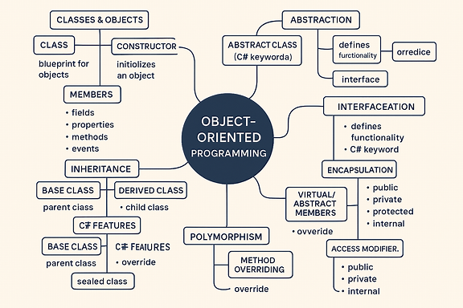
Here’s your complete OOP mind map in one image, covering all the major concepts and C#-specific behaviors you requested. Let me know if you'd like a version with even deeper branches—such as memory management, design patterns, or advanced runtime behavior.

السؤال:
Produce a detailed, expert-level mind map that visualizes all major and minor Object-Oriented Programming concepts in C#, including theoretical principles, design patterns, memory behavior, and code-level mechanisms, all combined into a single cohesive diagram.
الجواب:
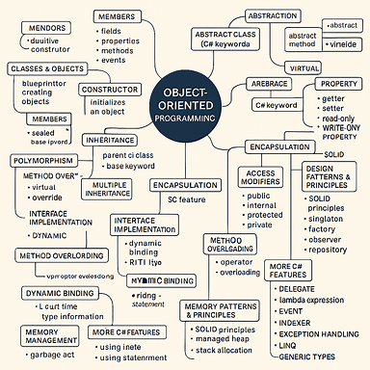
Your expert-level OOP mind map is ready now. It combines theoretical principles, C#-specific behaviors, design patterns, memory management, and code-level mechanisms into one cohesive diagram. If you'd like to zoom in on any branch—such as SOLID principles, runtime behavior, or advanced interface usage—I can generate focused expansions or layered breakdowns.

